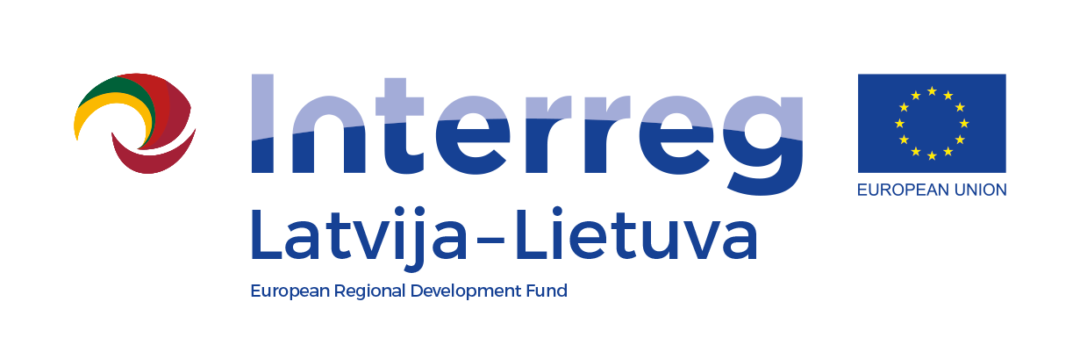
Privacy notice on the processing of personal data
within the project “Joint Management of Urban Wetland Areas in Border Region Latvia-Lithuania”
Urb-Area Nr.LLI-472

Updated: 11.02.2022.
Personal data processing controller: Daugavpils City Municipality (Development Department, Office of Investment and International Relations), address: Krišjāņa Valdemāra iela 13, Daugavpils, LV-5401, contact person of the controller: Olga Tolmačova, tel. 65404225, e-mail: olga.tolmacova@daugavpils.lv,
Communication with personal data protection officer: e-mail: dati@daugavpils.lv, or contact Daugavpils City Municipality, address: Krišjāņa Valdemāra iela 1, Daugavpils, LV-5401.
The controller processes your personal data within the project “Joint Management of Urban Wetland Areas in Border Region Latvia-Lithuania”/Urb-Area Nr.LLI-472 (hereinafter – the Project), which is implemented within the framework of the INTERREG V-A Latvia-Lithuania Cross-Border Cooperation Program 2014-2020 for the following purposes with the appropriate legal basis:
Processing aim, purpose (1) | Processing aim, purpose (2) | Categories of personal data | Data subjects | Legal basis GDPR | Beneficiaries or categories of beneficiaries | Storage (term)  years
Project implementation | Registration for seminars / roundtable discussions / eco-training events organized by partners | Name, surname, e-mail address, telephone number | Program participants (employees responsible for wetland area management in Daugavpils and Anykščiai municipalities, external experts, students, pupils, NGO representatives, residents of both municipalities | c) legal obligation  e) official authority | Daugavpils City Municipality (DCM) project management and implementation team | 5 years after project implementation (after the last payment)
Project implementation | Conclusion of agreements with experts on supervision of research in the application management system | Name, surname, e-mail address, telephone number | Experts | b) contractual necessity | DCM project management and implementation team, IT system maintenance specialists | 5 years after project implementation (after the last payment)
Project implementation | Research data processing | Name, surname, e-mail address, telephone number | Researchers | c) legal obligation  e) official authority | DCM project management and implementation team, experts, IT system maintenance specialists | 5 years after project implementation (after the last payment)
Project implementation | Publication of researcher's data in an application online with research materials | Name, surname, e-mail address, telephone number | Researchers | a) consent | DCM project management and implementation team, experts, IT system maintenance specialists | 5 years after project implementation (after the last payment)

Legal basis for processing (detailed):
Regulation (EU) 2016/679 of the European Parliament and of the Council of 27 April 2016 on the protection of natural persons with regard to the processing of personal data and on the free movement of such data, and repealing Directive 95/46/EC (General Data Protection Regulation):
- GDPR 6.1 (a) the data subject has given consent to the processing of his or her personal data for one or more specific purposes;
- GDPR 6.1 (b) processing is necessary for the performance of a contract to which the data subject is party or in order to take steps at the request of the data subject prior to entering into a contract;
- GDPR 6.1 (c) processing is necessary for compliance with a legal obligation to which the controller is subject;
- GDPR 6.1 (e) processing is necessary for the performance of a task carried out in the public interest or in the exercise of official authority vested in the controller.

The Beneficiary is obliged to collect, store and compile the personal data of the project participants (name, surname, contact information, video and/or photo) of the project activities (training, events, classes, conferences, etc.), who participate in the activities funded by the above mentioned project, providing the identification of participants and inclusion in project monitoring indicators. Such an obligation for Daugavpils City Municipality as a beneficiary of the Interreg V-A Latvia - Lithuania Cross-Border Cooperation Program 2014-2020 is determined by the Managing Authority, the Audit Authority and the Joint Secretariat for the implementation of the project on the basis of Agreement No AI/126/2020 (Daugavpils City Municipality Reg. No 1.-10.1/145). If such personal data is not processed, Daugavpils City Municipality does not have the opportunity to ensure the above-mentioned legal obligation to submit reports on the expenditure of funds.

As a Data Subject, you have the right to: request the controller to access, rectify or delete the data subject's personal data, or to restrict the processing related to the data subject, or the right to object to the processing.
The data subject has the right to submit a complaint regarding the processing of his or her personal data to the supervisory authority: Data State Inspectorate, Blaumaņa iela 11/13-11, Riga; https://www.dvi.gov.lv/lv/funkcijas/kontaktinformacija/, e-mail: info@dvi.gov.lv

